Aim

Set 19: Survey Responses Analysis
Data Visualization using R

To analyse survey responses using a grouped bar chart, a stacked bar chart, a table and a dashboard in R.

Procedure
- Open RStudio and load the packages ggplot2 and gridExtra (install them once with install.packages(c("ggplot2", "gridExtra"))).
- Create the survey data as a data frame.
- Question 1: draw the grouped bar chart of Question 1 answers with geom_bar(position = "dodge").
- Question 2: draw the stacked bar chart of all three questions with geom_bar().
- Question 3: make the table with tableGrob().
- Question 4: join the two charts and the table into a dashboard with arrangeGrob().
- Run the code and note the output and the figures.

R Code
library(ggplot2); library(gridExtra)

# Dataset
survey <- data.frame(Survey_ID = 1:3, Question1 = c("A","B","C"), Question2 = c("B","A","A"), Question3 = c("C","D","B"))
print(survey)
long <- stack(survey[, 2:4]); names(long) <- c("Answer", "Question") print(table(long$Question, long$Answer))

# 1. Grouped bar chart - Question 1
p1 <- ggplot(survey, aes(Question1, fill = factor(Survey_ID))) + geom_bar(position = "dodge") +
labs(title = "Answers of Question 1", x = "Answer", y = "Count", fill = "Survey ID")

# 2. Stacked bar chart - all questions
p2 <- ggplot(long, aes(Question, fill = Answer)) + geom_bar() + labs(title = "Responses of All Questions", x = "Question", y = "Count")

# 3. Table
tb <- tableGrob(survey, rows = NULL)

# 4. Dashboard
dash <- arrangeGrob(p1, p2, tb, layout_matrix = rbind(c(1,2), c(3,3)), top = "Survey Dashboard")

ggsave("set19_q1.png", p1, width = 6, height = 4, bg = "white") ggsave("set19_q2.png", p2, width = 6, height = 4, bg = "white")
ggsave("set19_q3.png", arrangeGrob(tb, top = "Survey Response Table"), width = 5, height = 2, bg = "white") ggsave("set19_q4.png", dash, width = 12, height = 8, bg = "white")

Output
1 1 A B C
Survey_ID Question1 Question2 Question3
- 2 B A D
- 3 C A B

A B C D
Question1 1 1 1 0
Question2 2 1 0 0

Question3 0 1 1 1
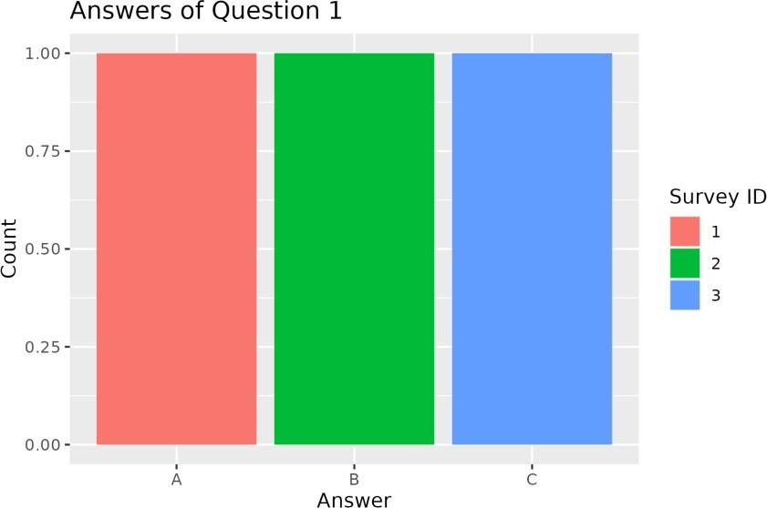
Figure 19.1: Q1 - Grouped bar chart (Question 1)
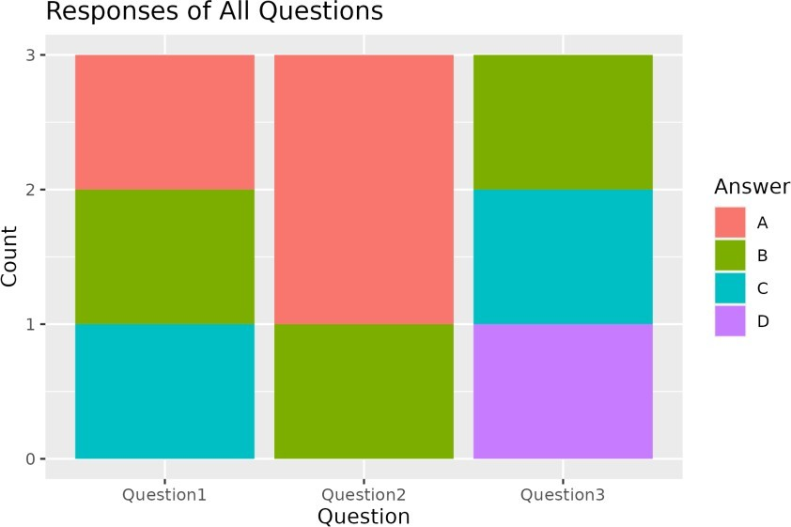
Figure 19.2: Q2 - Stacked bar chart (all questions)
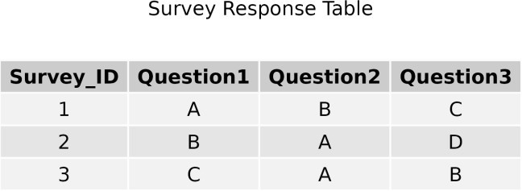

Figure 19.3: Q3 - Survey response table

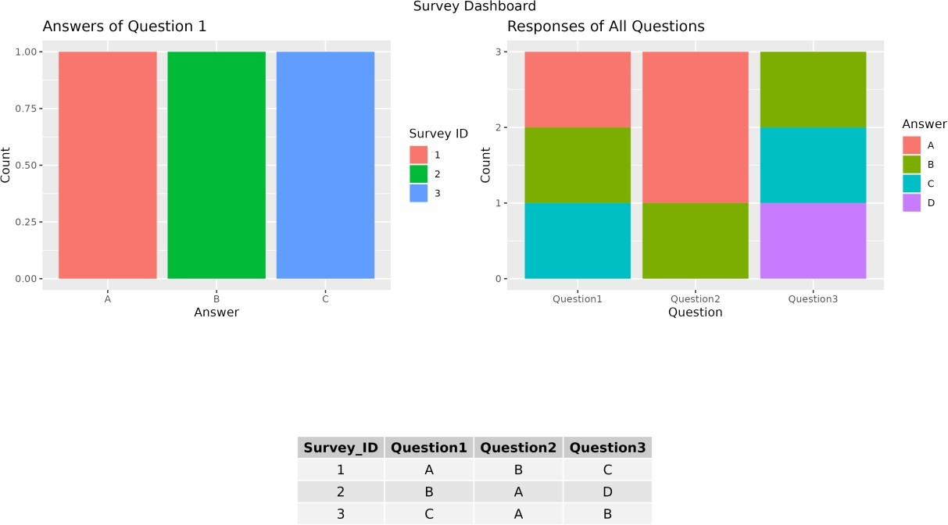

Figure 19.4: Q4 - Dashboard

Result
- In Question 1, answers A, B and C were chosen once each.
- Question 2 has A twice and B once; Question 3 has B, C and D once each.
- All four parts were completed successfully in R.

